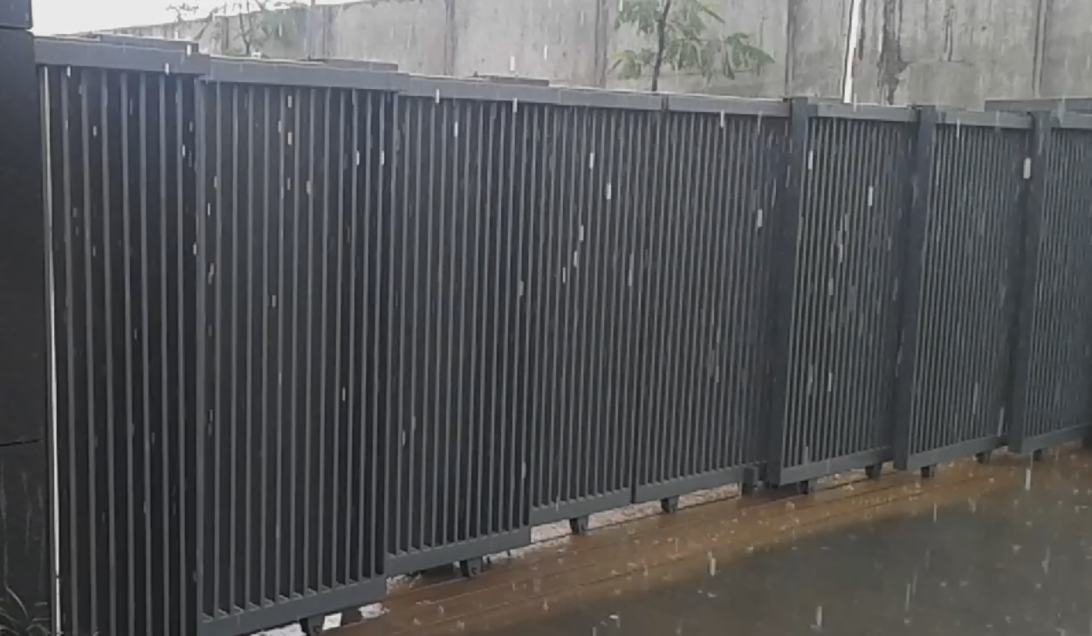

System Manual

Project No. | PR2016000006
Project Name | MOTORISED DOORS
Sub-Project | MOTORISED DOORS
Customer | LUPIN

System Identification

Project Code | PR2016000006
Project Name | MOTORISED DOORS
Manufacturer | Frontier Automation Robotics India Pvt. Ltd.
Office Address | India
  Plot No-1,Gat No-343,Behind Hotel Courtyard Marrite,
  Chakan Industrial Area
  Phase-1,
  Talegaon-Chakan Road,
  Mahalunge ,
  Pune – 410 501
Factory Address | India
  Plot No-1,Gat No-343,Behind Hotel Courtyard Marrite,
  Chakan Industrial Area
  Phase-1,
  Talegaon-Chakan Road,
  Mahalunge ,
  Pune – 410 501
Telephone No. | +91-7410015015
Email Address for Service
  enquiry@frontierautomation.in
Website | https://www.frontierautomation.in
GA Drawing No.
Customer PO No.
Project Dispatch Month & Year
Customer Name | LUPIN

Table 1: Identification Data

Foreword

We are pleased to forward this manual to you to provide guidelines on trouble free operation of the equipment, procedures for periodic and preventive maintenance, and troubleshooting. This manual consists of the description of equipment along with technical specifications, and operation procedures. For maintenance of ‘Bought-out’ equipment, please refer manufacturers’ manuals. We insist you to maintain necessary record (logbook) for ensuring proper preventive maintenance, to achieve trouble free production. We are sure; you will find this manual very useful and interesting. However, your suggestions and doubts if any are always welcome!

Frontier Robotics & Automation Pvt. Ltd

Manual Revision History

Print Date | Manual Type | Prepared By | Revision | Remark
22 November 2026 | System Manual | KETAN | First Copy

Table of Contents
1. System Identification 2
2. Table of Contents 4
3.Circuit Diagram...................................................................................................5
4. Maintenance & Troubleshooting 13
4.1 Safety Precautions - Dos and Don’ts 13
4.1.1 Do's of the system 13
4.1.2 Don’ts of the system 13
5. Spare & Wear Part Lists 16
5.1 Mechanical Critical Bought-out Parts 16
6. Appendix 18
6.1 Appendix 1 – Assembly & Wear Parts Drawings 18

3.CIRCUIT DIAGRAM

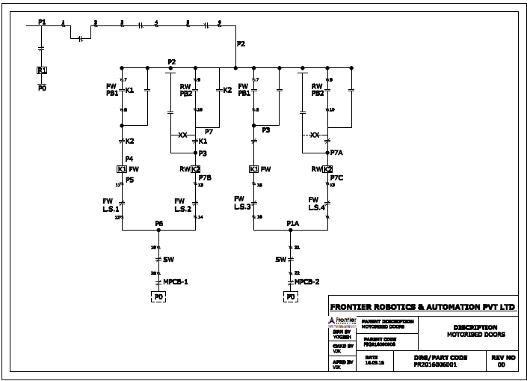

4. Maintenance & Troubleshooting

4.1 Safety Precautions - Dos and Don’ts

4.1.1 Do's of the system
- Power is switched off before entering into the Machine area for setting or maintenance.
- Press any E-Stop button (A red push button) and then follow the internal procedures of your company or organization for an emergency situation. Do not disconnect the power or Hydraulic supply to the system unless you are sure that nobody is trapped near the system. The E-Stop button is provided on Operator consol.
- Always ensure that system is” Switched off” while entering cell for maintenance or other activities.
- Use safety equipment’s like hand gloves etc.
- Use proper tools for the setting & maintenance activities.
- Clean the oil, dust & unwanted raw materials in the machine area after maintenance.

4.1.2 Don’ts of the system
- Do not set the system movements / programming with high speed.
- Do not bypass the limit switches of machines.
- Do not change the positions of the limit switches & dogs.
- Do not remove any covers.
- Do not lose the clamping screws on couplings, etc.
- Do not enter the machine when Auto cycle is ON.
- Do not alter the settings in the system.
- Do not put your hand while movement of torch slides while it is operating in given direction.
- Do not go away from the machine when machine is running.
 | – Note –  - Always maintain necessary logbooks for proper maintenance and Troubleshooting for trouble free production.

5. Spare & Wear Part Lists

5.1 Mechanical Critical Bought-out Parts

S NO | ITEM DESCRIPTION | QTY.
1 | HINDUSTAN MOTORS , 0.33HP 0.25 KW 4 POLE 1500 RPM B5 FLANGE MTG | 2
2 | BONFLIGLIOLI GEARBOX, VF44 V28 P71B5B3 WORM REDUCTION GEARBOX | 2
3 | SIMPLEX ROLLER CHAIN 1/2 INCH | 1 M
4 | LIMIT SWITCHES -TECHNIC | 4
5 | WIRE DRUM | 2
6 | CONDUIT-1 INCH & 2 INCH
7 | SIMPLEX SPROCKETS 1/2 INCH | 2
8 | SIMPLEX SPROCKETS 1/2 INCH | 2

- Appendix 1 -
MECHANICAL ASSLY DRAWING

Project No. | PR2016000006
Project Name | MOTORISED DOORS
Sub-Project | MOTORISED DOORS
Customer | LUPIN

